DOMAIN MODEL WITH MULTIPLICITY

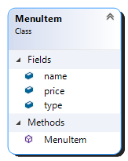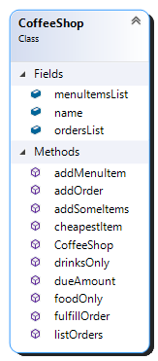

Contains

1

∞